ONLINE-Mall management system

This Project is all about Mall Management in which You can do Booking Shops ,Movies and You can Buy Food.

WEB

APPLICATION

**DOCUMENTATION OF E-PROJECT**

|  |  |
| --- | --- |
| **Waqas Qamar** | **Student_1060671** |
| **Farrukh Qureshi** | **Student_1053609** |
| **Maaz Khan** | **Student_1058677** |

|  |  |
| --- | --- |
|  |  |

**Submitted To :** [**eprojects@aptechfze.ae**](mailto:eprojects@aptechfze.ae)

**Project Instructor : SIR ABDUL WAHAB**

**Curriculum Code : 6673**



**INDEX**

|  |  |
| --- | --- |
| S.NO | PAGE IDENTIFICATION |
| 1 | **INTRODUCTION** |
|  |  |
| 2 | **ACKNOWLEDGEMENT** |
|  |  |
| 3 | **OBJECTIVES OF THE PROJECT** |
|  |  |
| 4 | **HARDWARE/SOFTWARE REQUIREMENTS** |
|  |  |
| 5 | **SOFTWARE USED** |
|  |  |
| 6 | **PROJECT DURATION** |
|  |  |
| 7 | **TASK SHEET** |
|  |  |
| 8 | **LIST OF VALIDATION** |
|  |  |
| 9 | **TEAM WORK** |
|  |  |
| 10 | **SUBMISSION CHECKLIST** |
|  |  |
| 11 | **ERD DIAGRAM** |
|  |  |
| 12 | **SCREENSHOT’S** |

**INTRODUCTION**

The thirst for learning, upgrading technical skills and applying the concepts in real life environment at a fast pace is what the industry demands from IT professionals today. However busy work schedules, far-flung locations, and unavailability of

convenient time-slots pose as major barriers when it comes to applying the concepts

into realism. And hence the need to look out for alternative means of

implementation in the form of laddered approach.

The above truly pose as constraints especially for our students too! With their busy

schedules, it is indeed difficult for our students to keep up with the genuine and

constant need for integrated application which can be seen live especially so in the

field of IT education where technology can change on the spur of a moment. *Well,*

*technology does come to our rescue at such times!!*

Keeping the above in mind and in tune with our constant endeavour to use

Technology in our training model, we at Aptech have thought of revolutionizing the

way our students learn and implement the concepts using tools themselves by

providing a *live and synchronous eProject learning environment!*

o Practice step by step i.e. laddered approach.

o Build a larger more robust application.

o Usage of certain utilities in applications designed by user.

o Single program to unified code leading to a complete application.

o Learn implementation of concepts in a phased manner.

o Enhance skills and add value.

o Work on real life projects.

o Give a real life scenario and help to create applications more complicated and

useful.

o Mentoring through email support.

**ACKNOWLEDGEMENT**

We are extremely grateful and remain indebted to our guide Sir ABDUL WAHAB KHAN for being a source of inspiration and for his constant support in the Design and development of the e-project. We are thankful to him for their constant constructive criticism and invaluable suggestions, which benefited us a lot while developing the e-project on **“Web-Application MALL MANAGEMENT SYSTEM”.** He has been a constant source of inspiration and motivation for hard work. He has been very co-operative throughout this e-project work. Through this column, it would be our outmost pleasure to express our warm thanks to him for their encouragement, co-operation and consent without which we mightn’t be able to accomplish this e-project.

We also express our gratitude to Aptech for providing us the infrastructure to carry out the project and to all staff members who were directly and indirectly instrument in enabling us to stay committed for the **e-project**.

**OBJECTIVES OF THE PROJECT**

The Objective of this program is to give a sample project to work on real life projects. These applications help you build a larger more application.

The objective is not to teach you the concepts but to provide you with a real life scenario and help you create applications using the tools.

You can revise them before you start with the project.

It is very essential that a student has a clear understanding of the subject.

Kindly get back @ eprojects@aptechfze.ae in case of any doubts regarding the application or its objectives.

In the first phase all the faculties are requested to try out all the problems and then revert back if any problems are there. You can mail at eprojects@aptechfze.ae

**Hardware/ Software Requirements**

**Hardware:**

* A minimum computer system that will help you access all the tools in the courses is a Pentium 166 or better
* 128 Megabytes of RAM or better

**Software:**

Use software as per your requirement

* Win-10/Visual Studio .net / C# /

**SOFTWARE USED**

## ADOBE PHOTOSHOP CS4

We use this software to create design our Project logo and pictures. Through this software we can easily utilize all the tools of graphics.

## Microsoft Visual Studios 2013

We have used this software for developing and designing panels, buttons and many more in our project.

## SQL DATABASE 2015

We have used for making data for the **e-project** to manage into Pages.

# PROJECT DURATION

1. Analysis -1 -7.
2. Logo Design - 4-16.
3. Database - 9*--28.
4. Testing - 26-30.
5. Documentation - 1-7.

|  |  |  |  |  |
| --- | --- | --- | --- | --- |
| **Analysis** | **Logo Design** | **Database** | **Testing** | **Documentation** |

|  |  |  |  |  |  |  |  |  |  |  |  |  |  |  |  |  |  |  |  |  |  |  |  |  |  |  |  |  |  |
| --- | --- | --- | --- | --- | --- | --- | --- | --- | --- | --- | --- | --- | --- | --- | --- | --- | --- | --- | --- | --- | --- | --- | --- | --- | --- | --- | --- | --- | --- |
| 1 | 2 | 3 | 4 | 5 | 6 | 7 | 8 | 9 | 10 | 11 | 12 | 13 | 14 | 15 | 16 | 17 | 18 | 19 | 20 | 21 | 22 | 23 | 24 | 25 | 26 | 27 | 28 | 29 | 30 |

* Each phase must be complete as shown by the lines.
* The team would meet day by day and evaluate their progress. Detailed progress plan to be drawn to access progress of the project.
* As it can be noticed that there are overlapping of process this is kept because certain process can go hand in hand with other processes.

**TASK SHEET**

|  |  |  |  |  |  |
| --- | --- | --- | --- | --- | --- |
| S.No | Task | Project Title | Actual Start  Date | Actual Days | Status |
| **OMMS** |
| 1. | Analysis | | 18-Jun-2019 | 2 | Completed |
| 2. | Logo Design | | 23- Jun -2019 | 2 | Completed |
| 3. | Database | | 28- Jun -2019 | 7 | Completed |
| 4. | Development | | 5- Jul -2019 | 12 | Completed |
| 5. | Testing | | 13-Jul-2019 | 2 | Completed |
| 6. | Documentation | | 15-Jul -2019 | 2 | Completed |

**PRODUCT ASSISTANCE**

* Click on “Entertainment” to view different types of Movies.
* All Movies have proper Categaries Front of every Movie.
* Select Any Type of .
* All Types consist different Movies,Food and Shops with their specifications.

**LIST OF VALIDATION**

|  |  |
| --- | --- |
| OPTIONS | VALIDATION |
| All Forms have link back to Main Form | Yes |
| All Functions Are Compatible with  Visual Studios | Yes |

**TEAM WORK**

**SUBMISSION CHECKLIST**

|  |  |  |  |  |
| --- | --- | --- | --- | --- |
| S.No | LIST OF ITEMS | YES | NO | COMMENTS |
| 1. | Do All Frames Linked together | Yes |  |  |
| 2. | All Frames working | Yes |  |  |
| 3. | Frames Colors As Per Common Guidelines | Yes |  |  |
| 4. | Visual Studios Compatible | Yes |  | Tested In  Visual Studios 2013 |
| 5. | Project Zip File | Yes |  | Created using  WinRAR |

# ERD DIAGRAM

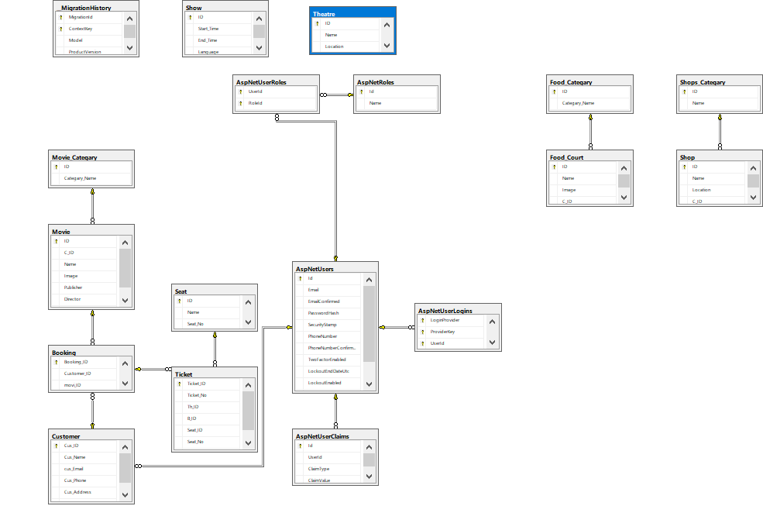

**SCREENSHOT’S**

# Home Page

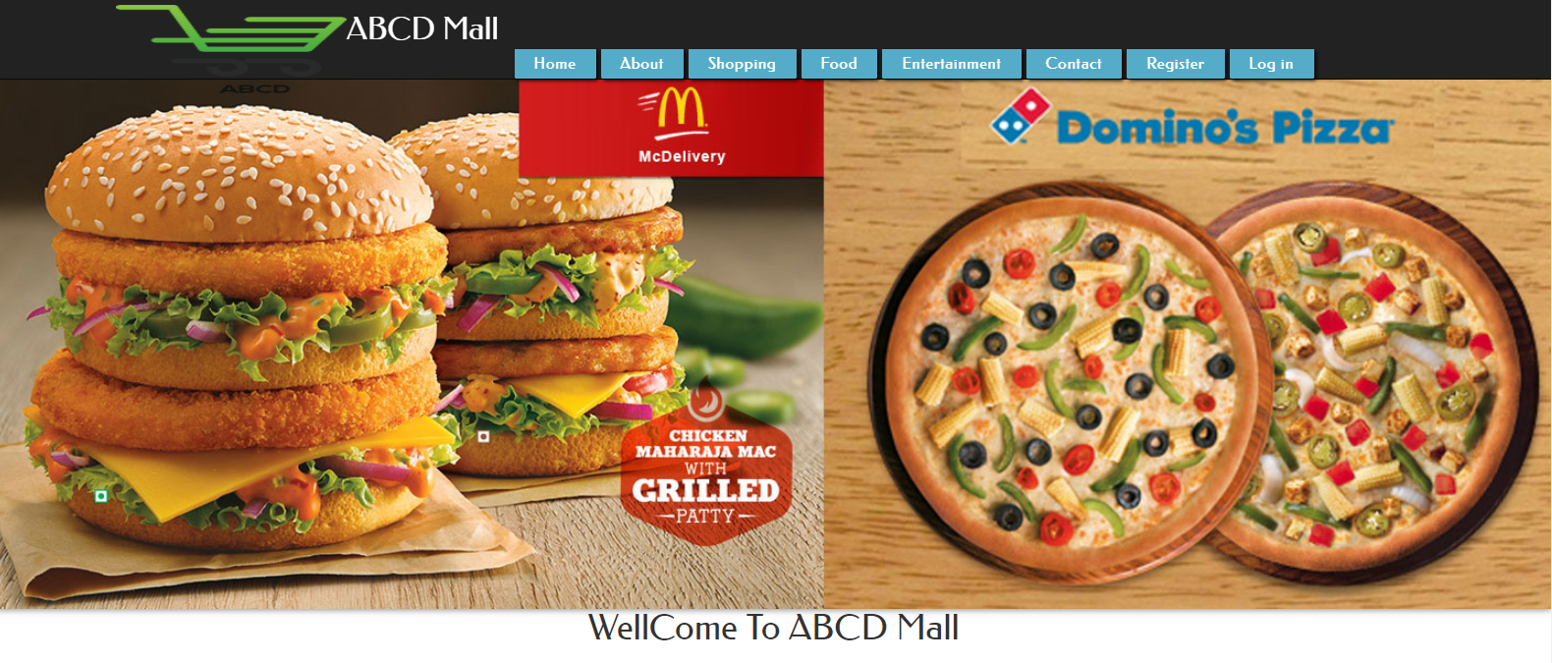

# Shopping Page

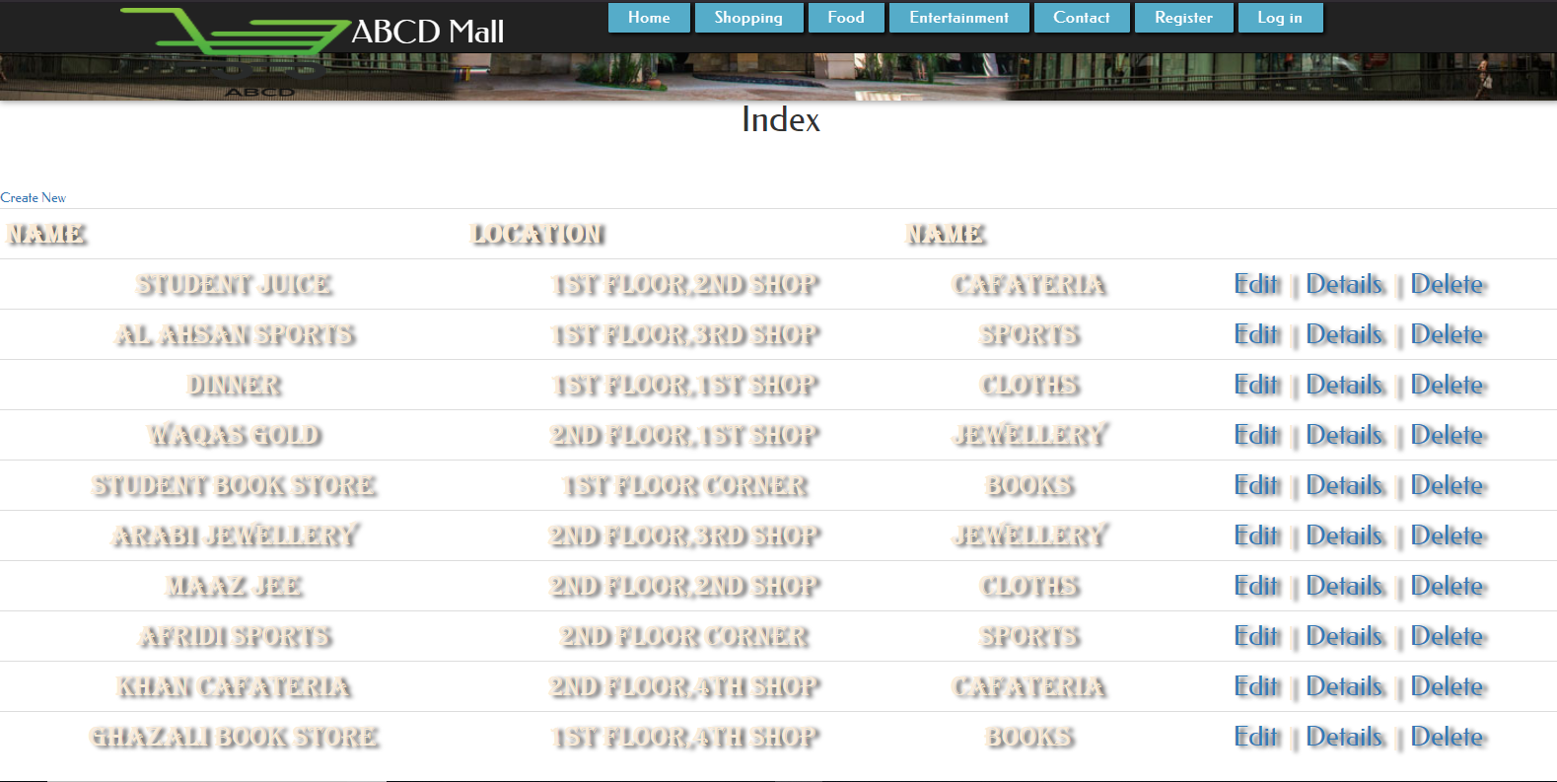

# Food Page

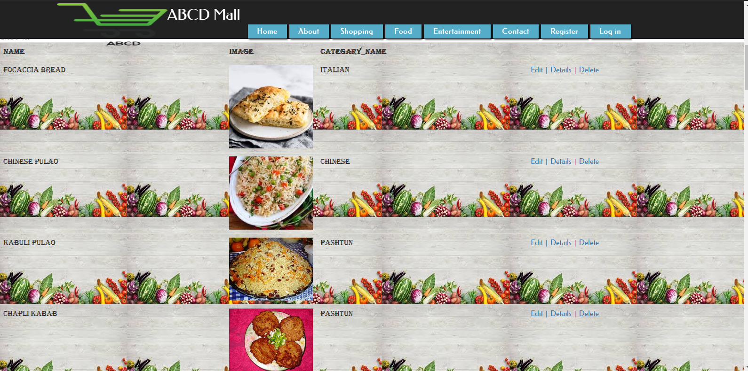

# 4. ABOUT US

# ABOUT US.PNG

# CONTACT US

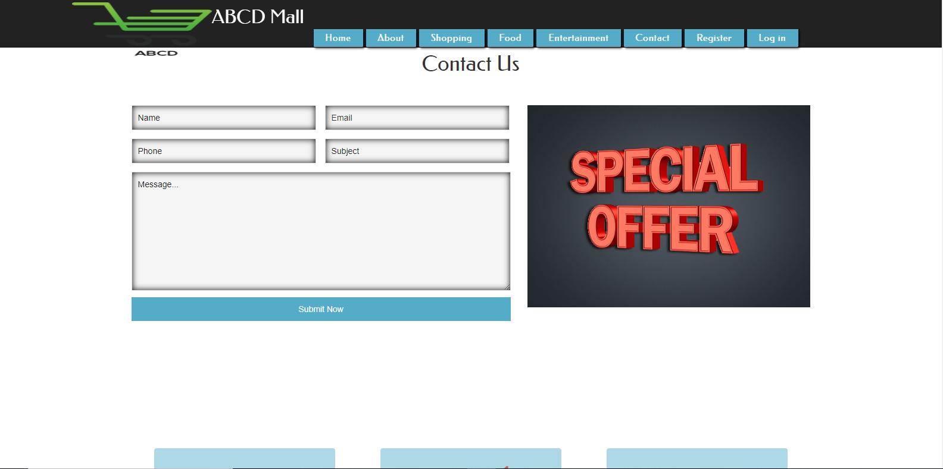

# LOCATE US

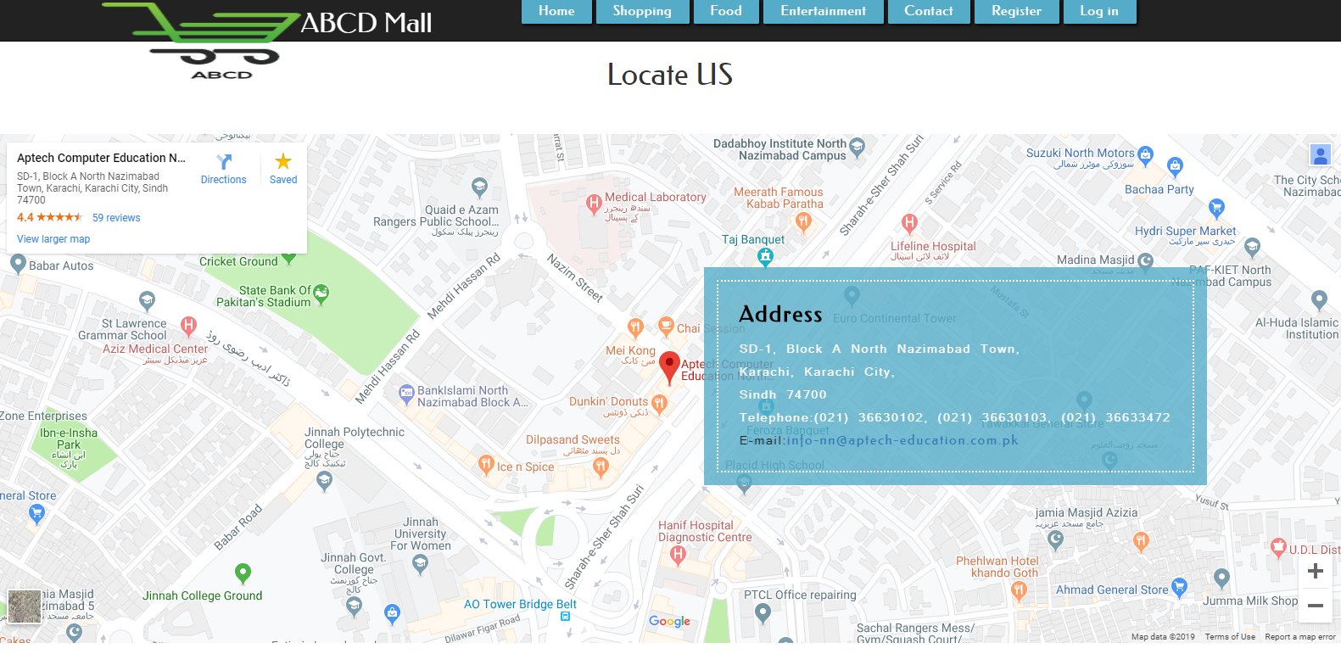

# 6. Entertainment Page

